<EMPTY>

The current city council is not doing enough for the residents and businesses of El Cajon. There is little energy, decisions are not being challenged, there is a lack of new ideas, the budget needs to be better managed, and there is a lack of key business fundamentals.

I will bring a new energy, a new focus, and that private sector business mentality to the council.

I will challenge the “Status Quo”.

Vote

Duane Swainston

El Cajon City Council

November 2012

**Vote**

**Duane Swainston**

**El Cajon City Council**

**The Clear Choice**

**“For A Better El Cajon”**

Email: dswainston@live.com

Follow on Twitter: @OTLTree

**For more Information On Duane Swainston**

**Visit his Website at:**

www.dswainston4council.weebly.com

Duane Swainston

The Clear Choice

“For A Better El Cajon”

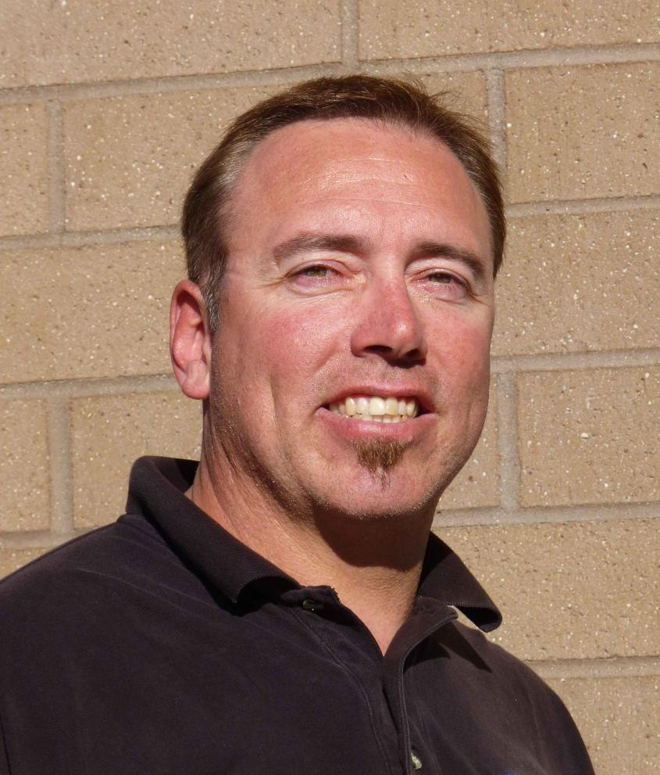

Delete text and place photo here.

# Why Vote for Somebody New?

<EMPTY>



Delete text and place photo here.

At a political forum

Photo courtesy of East County Magazine

#### Duane Swainston

Has the Education, Business Knowledge, and Life Experience that El Cajon needs

on the city council

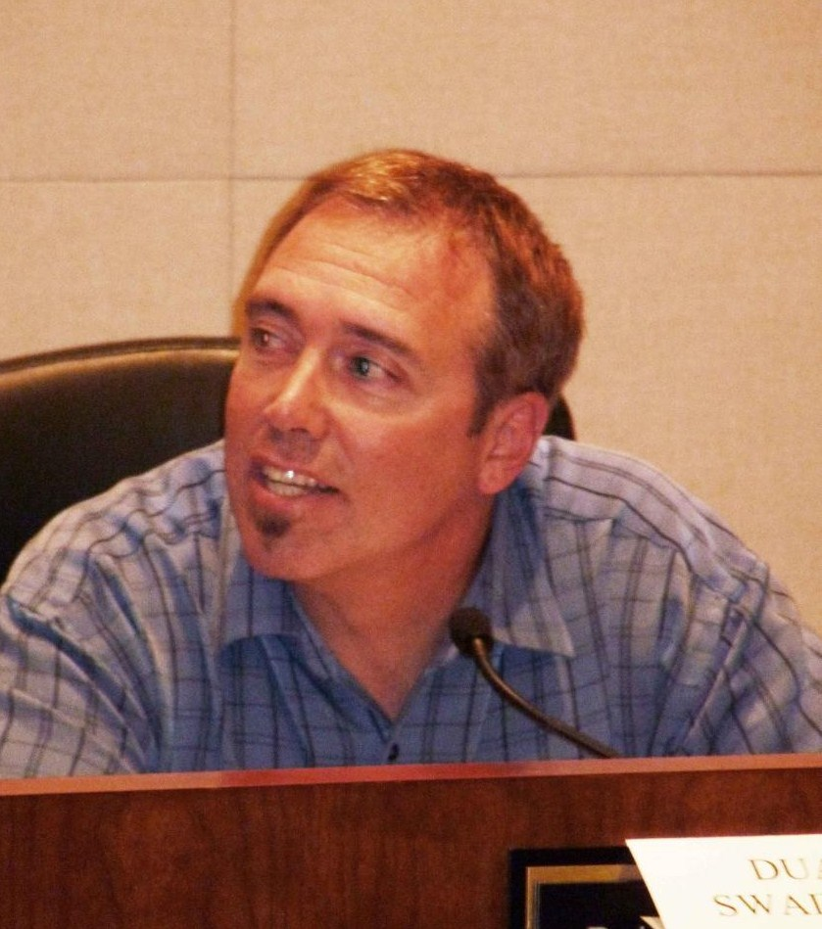

Delete text and place photo here.

* Duane has lived in the East County for 32 years.
* He has been in the manufacturing industry in El Cajon for 25 years.
* He has owned a small business in El Cajon
* He graduated high school and college in East County.
* He has been involved with the off-road community. Having participated in District 38 events.
* Duane is determined to make El Cajon more efficient and fiscally sound. He has a Bachelor’s Degree in Business Management. He will take his business experience from the fast paced, cost conscious, quality focused, schedule dominant, world of aerospace manufacturing and transfer it over to city government.
* Duane is dedicated to the business needs of El Cajon. He will work to bring businesses and its consumers back to El Cajon.
* Duane is focused on the residents of El Cajon. He will say “NO” to rate and tax hikes. He will ensure that emergency services remain intact. As a board member of The ECPAC Foundation he is striving to bring “Arts and Entertainment” back to El Cajon.

Duane has been married to his wife Linda for 23 years. They have two children, Braxton and Breasha. They have lived in El Cajon for the past 18 years. They attend and are actively involved at Foothills Christian Church.

**Duane Swainston**

Understands the needs of

El Cajon and East County

#### Duane Swainston

A Family Man, with Strong Character

and a Commitment to Family Values

Linda, Duane, Breasha, and Braxton